Dan Pollard Internship report
My six month internship here at the Galloway Fisheries Trust has truly been an invaluable experience for me, I was given the opportunity to develop crucial skills needed for this line of work, and with the help of all the staff at GFT, I have done just that. Both through experiencing field work first hand and a number of useful and relevant training courses. Prior to my internship I did have some experience working with GFT as a volunteer and Field assistant, which gave me limited insight to what was actually going on, but through the internship I have gained a much deeper understanding of why the trust do what they do as opposed to just seeing what is happening on surface level. I see now that that things such as habitat works are not just done on a whim wherever it seems possible. Rather, there is a lot of planning and careful thought that goes into what kind of habitat restoration is done, and also where it is done to have the most beneficial effects on some priority areas along with some of the more degraded areas. I was fortunate enough to get involved with some of this planning, going out looking at a burn, working with a land owner and reaching a desirable compromise that allows us to now go ahead and conduct habitat works without negatively impacting the land owner and therefore hopefully forming a positive relationship with the landowner which will hopefully lead to them allowing more habitat restoration works to take place on their land in the future. This opportunity allowed me to not only work as part of a team but also autonomously on a few projects which in turn boosted my problem solving skills and more importantly, in my opinion, my confidence in my work. Being forced to carry out tasks and problem solve primarily by myself in some cases allowed me to see that I am more capable than I had once thought, which comes as a great relief as one of my main personal goals going into the internship was to try improve my self-confidence as it was a bit lacking in the past and was sometimes a rather large hurdle for me to overcome.

Key Works and Projects

Black Water of Dee (BWoD) Habitat Restoration Project:
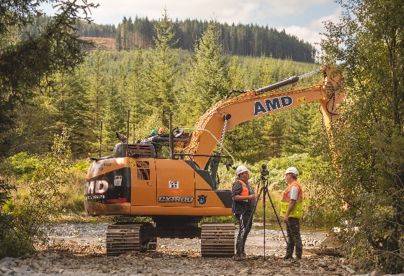
I was fortunate enough to be involved with overseeing the habitat works that took place on the Black Water of Dee. It is an amazing example of habitat restoration as, all going well, we can hope to see salmon return to the river to spawn in gravels which were previously absent. There were around 450 tonnes of gravel taken from further up the catchment where they had begun to block a hydroelectric intake that were then repurposed an added at a number of sections along the BWoD to then be washed downstream and naturally deposited to form spawning beds for salmonids. These works were a long time in the making and involved a number of stakeholders that GFT had to regularly liaise with in order for the works to go ahead, that is why I believe this project was so beneficial to me as it has shown me the importance of communication between ourselves at GFT and everyone else involved so that a project can run smoothly and achieve the best outcome. Even after the works were completed there has been continued discussion between GFT and their stakeholders and the possibility for the works to continue in the future.
Getting interviewed by Nick Chisolm alongside the BWoD restoration works

Lorg wind farm pre-construction electrofishing:
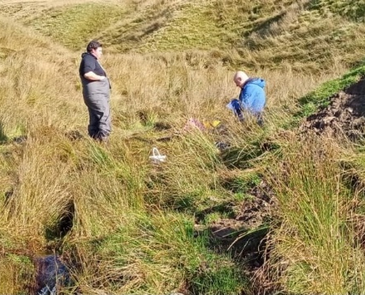
When a wind farm is going to be constructed, it is important that organisations like GFT complete pre-construction checks to make sure that when the wind farm is being built it will not have any major adverse effects on local biodiversity, and more specifically in our case any local fish populations. We can then advise companies on how to proceed with the necessary precautions in place to prevent any harm to fish. I was given a key role on this project which gave me experience being in charge of a team, mapping out sites to electrofish and helping to write an official report. This is not the only time I have been in charge of a team, I also led a volunteer day on the upper Luce where we replanted trees that had died and fixed up any tree guards and stakes that had blown over since they were planted earlier in the year. These opportunities allowed me to develop my organisational, coordination and leadership skills, it also allowed me to experience writing RAMS (Risk Assessment and Method Statement) which is an important part of all GFT field work.
Myself and Jamie after electrofishing a burn for Lorg wind farm

Field Work:
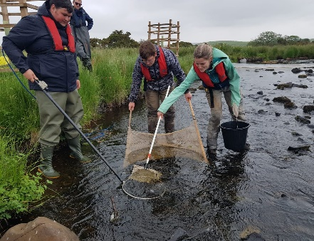
- Electrofishing
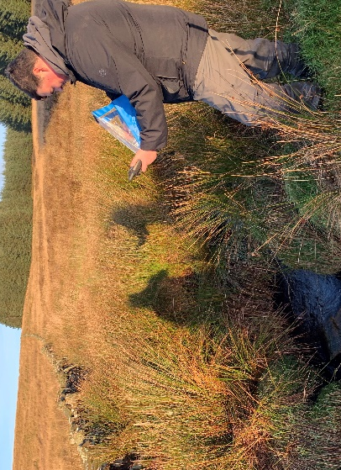
Over the course of the summer, we were all very busy electrofishing for a large proportion of our time, this type of repetition working in electrofishing teams was an excellent tool for me to improve not only my electrofishing skills, but also my ability to work effectively in a team. Another benefit of conducting a lot of electrofishing surveys is that you get a feel for the different types of habitat that fish seem the prefer, depending on the species, which then allows you to get an idea of how healthy some water courses might be purely by observing its physical features. This also comes in handy when conducting habitat restoration works as, if you know which types of habitats the fish tend to favour, then it is much easier to replicate and produce such habitats through things like green engineering.
Electrofishing the Malzie Burn

- Habitat surveying
Leading on from my previous point, if you know what kind of things to look out for in a healthy and productive water course then you also know what indicators to look out for that would suggest a river/burn is maybe more unsuitable for fish. This can then be applied to habitat surveys where you can highlight any possible problematic areas such as those with little to no substrate, lack of dappled shade and woody debris. Before my internship ended I had the opportunity to apply this in practice and assist with a habitat survey and thanks to all the knowledge and experience I had gained over the past 5-6 months I realised that I already knew everything that I needed, in order to conduct a habitat survey and I just needed to bring it all together, which made it a lot easier for me and even allowed me to personally survey a section of the burn myself.
Habitat surveying

- Invasive Non-Native Species (INNS)
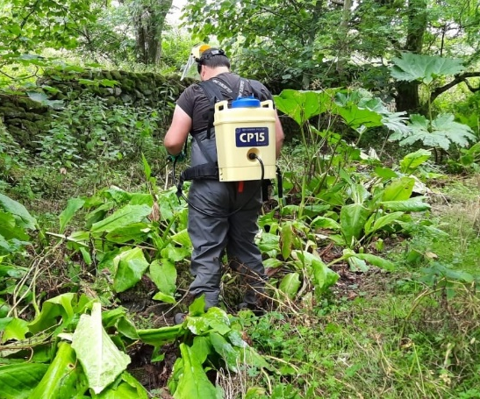
Another large part of what I have been doing at GFT is controlling INNS, more specifically invasive plant species such as giant hogweed, Japanese knotweed and skunk cabbage. To do this you need to gain an understanding of the characteristics of each invasive plant species. For example; what they look like, so you can target them more easily; when they seed/flower, so you know when is best to spray them; and how they spread, so you can avoid accidentally causing them to spread further as opposed to controlling their spread. You also need to know the correct ratio of water to chemical that is safe to use while still being effective. There is more to it than just knowing these few fundamental things so it is best that before you start spraying INNS, you do as I did and research each plant and the chemical that you are using so that you can be more safe and effective, for example I found out through research that knotweed is able to grow an entire new plant from just a small fragment of leaf and that giant hogweed contains sap that can cause some pretty major bodily harm to you if you get it on your skin.
Spraying Skunk Cabbage

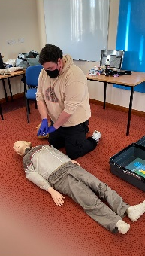
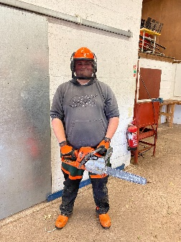
Training
- SFCC electrofishing course
- Emergency first aid course
- Experienced ATV operator course
- Chainsaw crosscut and maintenance course
- RRC Introduction to hydromorphology course
- ArcGIS pro course
- RRC Erosion management (Running in January 2022)
- Tweed Forum riparian tree planting workshop
First aid and chainsaw training course
Skills That I Have Developed:
- GIS
- Report writing
- Invasive control
- Organisation
- Surveying
- Public speaking
- Invasive plant control
- And much more

- Teamwork
- Leadership
- Confidence
- Communication
- First aid
- Electrofishing
- ATV operation
- Chainsaw operation

